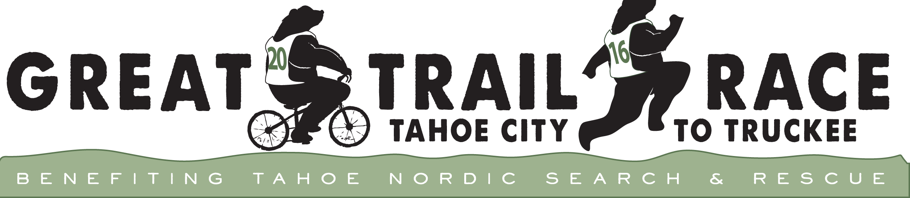

For release, 9/2/16:

A New Tahoe Tradition is Born!

The first annual Great Trail Race will be held October 9, 2016. Embodying the spirit and purpose of The Great Ski Race, the Great Trail Race will include fun but spirited competition and serve as a fundraiser for Tahoe Nordic Search and Rescue.
Following roughly the same route as The Great Ski Race—Tahoe City to Cottonwood Restaurant in Truckee—the Great Trail Race includes trail running and mountain biking competition in both Elite and Classic divisions, competing for overall, age group and team prizes. Both Elite and Classic courses are approximate 30 kilometers (19 miles) in length. Classic runners and mountain bikers compete on both paved and dirt sections of roads and fire roads leading from Tahoe City to Truckee. Elite runners and mountain bikers will divert from the route onto more technical, single-track sections of trail.
Teams of two will feature one runner and one mountain biker following the Elite course. Teams of three to five will compete in either running or mountain biking divisions, with only the top three times counted. If multiple teams in specific categories participate—i.e., high school, fire/law enforcement, families—top finishers in those categories will be awarded prizes.
As with its winter cousin, less serious racers can enjoy a fun and beautiful ride, run or walk, or make the event a goal of training, wearing the t-shirt with pride year around. The event is sanctioned by Tahoe Nordic Search and Rescue and produced by the experienced event management team at Big Blue Adventure.

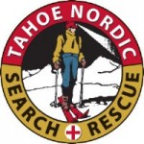40 Years of Saving Lives!

Tahoe Nordic Search and Rescue Team (TNSAR) was conceived in 1976 in response to the death of a local boy, Lance Sevison, in a blizzard. The all-volunteer Team has in the years since rescued over 500 people and conducted over 300 searches throughout the greater Tahoe Sierra.

Forty years ago, when Lance and a friend went missing off the backside of Northstar ski resort, there was no organized backcountry rescue team to help in the search. Desperate phone calls to local Nordic skiers, snowmobilers and snowcat owners produced a search party that eventually located the boys, but for Lance it was too late. This group of skiers, along with the boy’s father, learned there was an important void to be filled. TNSAR was born.

The Team has matured considerably over four decades but the mission remains the same: Conducting fast, safe rescues 12 months of the year and educating the public on winter safety. TNSAR does not charge for their services nor has anyone in the organization ever taken a paycheck.

TNSAR has been largely supported by its primary fundraiser — “The Great Ski Race,” held at the beginning of March. In some years, the event was the largest cross-country ski race west of the Mississippi. Although the event was held this past spring, in recent winters the race has been cancelled due to lack of snow. We hope the Great Trail Race will grow into a new, reliable annual funding source for TNSAR and a fun and successful community event during the fall “shoulder season.”
For more information or to register, go to www.GreatTrailRace.com.

Or contact:
Chaco Mohler, chacocmohler@gmail.com, 530-583-9460
Todd Jackson, todd@bigblueadventure.com, 530-546-1019
Chris McConnell, President TNSAR, mcspeed@gmail.com, 916-996-8500

